**Website Audit for gamefacetraining.com**

Search Engine Optimization, or SEO, is essential to the marketing success of modern businesses. We help companies develop SEO strategies that attract organic website traffic and generate high-quality leads. This SEO audit has been prepared for **gamefacetraining.com**

1. **Traffic Analysis:**

We have done an analysis of the website and found that there is a drop in traffic to the website in September 2022 as compared to July 2022. There is no consistent growth in the website traffic. I have found that there are lots of SEO opportunities to increase website traffic again.

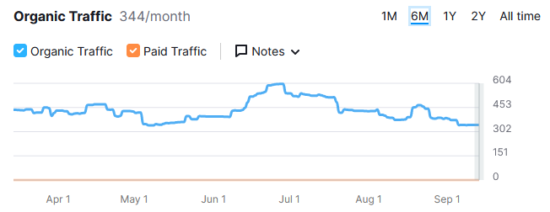

**Note:** It’s information from an SEO tool. We will do a more detailed analysis after getting your Google analytics access.

**Our Proposed Solution:**

Our suggestion is to improve organic traffic for **gamefacetraining.com**:

1. Improve ranking for our target keywords in SERP (Search Engine Results Page) with On-page and Off-page optimization
2. Optimize your website content - "Content is king"
3. Regular blog posting
4. Search console analysis (query and page analysis)
5. Examine analytics data
6. Secure more referral traffic
7. Make sure your site is fast
8. Research the competition and out-maneuverer them on SEO (ethically and responsibly, of course)
9. Create content that appeals to influencers and referral sources
10. Improve the firm’s organic click-through rate

**B) Keywords Analysis:**

I have checked the ranking for some of the keywords and found that some have good search volume but are not ranking at higher positions due to a lack of on-page and off-page nodes.

<https://docs.google.com/spreadsheets/d/1_wCuY3chjsHkfOPC_Q_zfPgMdqp8b6j-H3urOjWMH6Y/edit#gid=0>

**C) Competitor Analysis**: I have done a Competitor Backlinks Analysis. In the following tables, you can see that **bodybyboyle.com,** **traininghaus.com,** and **elitetrainingperformance.com** have 3698, 1454, and 310 backlinks from 533, 74, and 12 unique domains while **gamefacetraining.com** has 204 backlinks from only 53 referring domains. It means if we need to create more quality links with new fresh referring domains then we definitely rank at the top.

| **Website** | **Backlinks** | **Ref. Domain** | **Indexing** |
| --- | --- | --- | --- |
| gamefacetraining.com | 204 | 53 | 32 |
| **Competitors** | **Backlinks** | **Ref. Domain** | **Indexing** |
| bodybyboyle.com | 3698 | 533 | 160 |
| traininghaus.com | 1454 | 74 | 183 |
| elitetrainingperformance.com | 310 | 12 | 37 |

**D) General Analysis:**

In this section, I have listed some of the most important SEO factors that are important for website rankings.

| **Elements Analyzed** | **Findings** | **Why this Matters** |
| --- | --- | --- |
| Web Address Age: | Your website age is 10 Years 160 Days Old | Search Engine Algorithms measure a variety of parameters. Domain age is a big one that improves the overall score. |
| PA & DA | Currently Status is **DA 16 & PA 32** | Page Authority measures the predictive ranking strength of a single page; Domain Authority measures the strength of entire domains or subdomains. After Google Rank off, Now website quality Is measured by PA & DA. (Given by MOZ) |
| Number of Indexed Pages on your site | 32 pages are indexed in Google | When Google indexes a page, it tells us that Google knows it exists. The entire Website is indexed in Google. |
| Backlinks (Number of External sites linked to your site) | **204 backlinks from 53** unique domains | Backlinks are one of the primary areas of emphasis and score improvement for us. Search Engines index a site’s pages every time a link is made from another site. |
| Does this site have an XML site map? | Yes, **but not optimized** | An XML site map is a search engine-friendly map that is coded specifically to help search engines quickly find and retrieve the information from your site. This file plays a vital role in the optimization process. |
| Meta Tag and Title Analysis | Titles exist **but are not optimized** | Meta tags are in the form of a description and keywords tag. A meta description is present on most of the pages, but we need to optimize them. |
| Image Tag (Alt Tag) Analysis | **Missing** | Search Engines can only see and retrieve text. Images become wasted space on a page. To make the best use of the image areas, SEO experts will place important keywords in these image tags so the engine can use them**.** |
| Does a Robot File Exist | Found | This file is important because it is your website’s way of giving instructions to search engines about how to index your website. |
| Does This Site Use Search-Engine Friendly Footers? | Yes | The footer hyperlinks that you sometimes see at the bottom of a web page are done in a keyword-focused way, and can be very powerful in the search engine optimization process. It allows another opportunity for content to index and improves your rankings. |
| Keyword Density | **More opportunity to add keywords** | This is the whole reason search engines even care about your site. It is critical that pages have a nice balance of keywords that we identify are best from our research. |
| Website Home Text Content | **Opportunities to add more content** | The search engines can only index text content and cannot see the flash. |
| Structured Data | **No** | Schema code is important for local SEO ranking. It helps Google to understand correct business information. |
| Are Page URLs Named Effectively? | **Needs to be optimized** | The URL is where a search engine starts its journey. Each page of a site has a URL. Adding a keyword to the name gives the search engine more to work with. |

**E) Website Speed:**

Website speed is one of the important factors for website ranking. In page speed analysis, we have found website speed is poor on mobile devices and average on desktop according to **Google Pagespeed Insights Tool.**

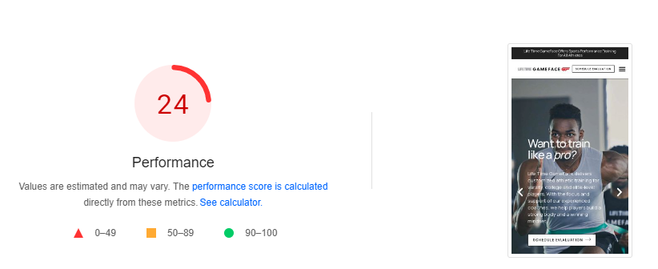

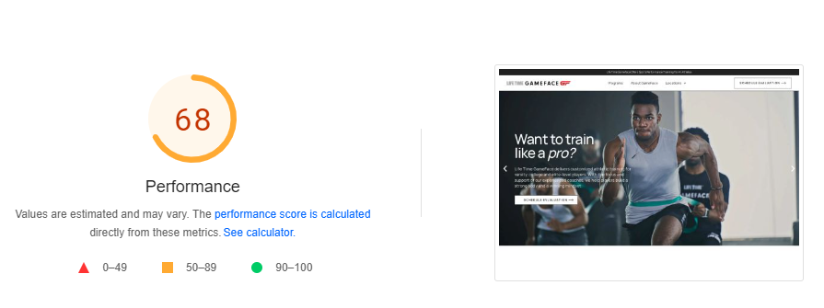

**F) Schema Code Suggestion**:

I have found that the category schema is not present on the website. We need to add a category and review & rating schema for the website. Schema markup is code (semantic vocabulary) that we put on the website to help the search engines to provide more informative results for users.

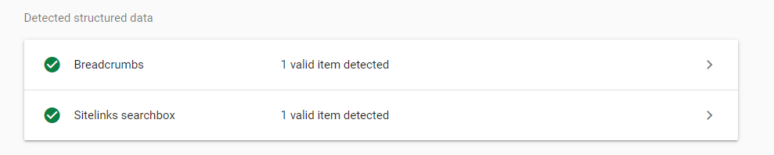

**G) On-Page SEO Analysis:**

After analyzing the complete website, I have found that there are many opportunities for optimizing the website in terms of different on-page factors:

1. **Title:** During the analysis, I found that meta titles are not optimized on any page. we need to optimize the title on all web pages with proper primary and secondary keywords which should contain 60-65 characters title length.

**Example:**

<https://gamefacetraining.com/>

**Current Title:**

Home - Life Time GameFace Training - Elite Sports Training

**Suggested Title:**

Sports Performance Training Programs - Elite Sports Training

**H) Backlinks Analysis:**

Backlinks are important for any website’s ranking. Good and high-quality backlinks help to improve keyword ranking. We have seen that **gamefacetraining.com** is not getting a good amount of backlinks i.e. only 204 backlinks from 53 referring domains.

**Screenshot:**

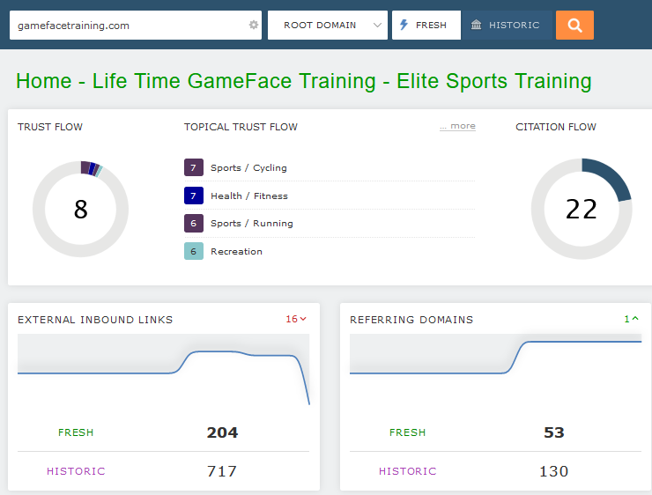

**I) Duplicate H1:**

During website analysis, I found some pages with duplicate H1 headings. Search engine crawlers prefer content that is structured properly and has a hierarchy when it comes to heading tags. The H1 tag is the most important and tells search engines what it is your content is about. Here is the screenshot:

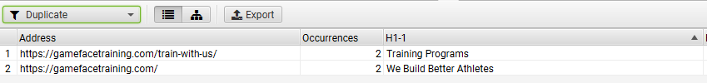

**J) Multiple H1:**

During website analysis, I found some pages with multiple H1 headings. Search engine crawlers prefer content that is structured properly and has a hierarchy when it comes to heading tags. The H1 tag is the most important and tells search engines what it is your content is about. There should be only one H1 for each website page. Here is the screenshot:

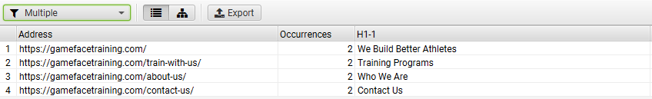

**K) Missing Alt Tags:**

During website analysis, I found some images without alt tags. Alt tags provide context to what an image is displaying, informing search engine crawlers and allowing them to index an image correctly. Here is the screenshot:

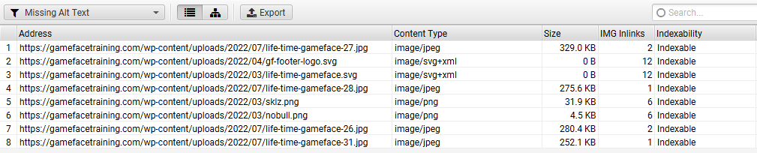

**L)** **Broken Links Issue**:

During the website analysis, I found some broken links on the Website. Broken links affect the SEO of a website because it affects user experience which is a ranking factor. These links could be quite annoying causing a poor experience. Here is the screenshot:

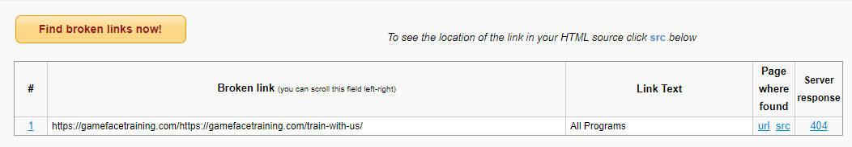

**M)** **Content Analysis:**

**Low Amount of Content**

During website analysis, we have found that the website doesn’t have enough content on all of the important pages which search engines can interpret as **thin content**. It has been well researched that higher text content volumes are related to better ranking ability in general. You can see the competitors' sites and find that they have more resource pages like articles and FAQ sections.

**N) GMB Analysis:**

During GMB Analysis, I have noticed that we have a Google Business Profile page with the following missing information. There are still lots of opportunities to optimize the GMB profile to obtain a higher local ranking. Here is the information that needs to be fulfilled along with the screenshot:

* **Reviews** - We have only 1 review from the last 1 month. Also, We need to reply to the reviews whether positive or negative. By having more positive reviews on the google business profile page there are more chances to rank higher in the local pack.
* **GMB Posts**: We noticed that we do not have any content posted on GMB. It is suggested to post new and relevant content about your business, which can help you reach more customers and entice them to interact with your business directly from Google Search.

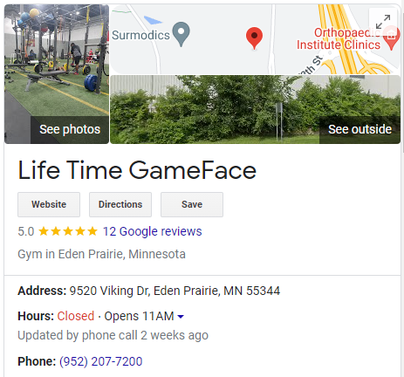

**O) Citation Analysis:**

We have done a citation analysis for **gamefacetraining.com** and found that our business information is incorrect and missing on most of the websites. Here is the screenshot:

